**NSS STATA TEST OUTPUT**

**Q1. Compute the marginal distribution of caste (SC/ST/OBC/General) and sex (Male, Female) in the individual population.**

Please refer to “Table1” and “Table2” sheet of “test_results.xlsx” file for the marginal distribution of caste and gender respectively. Major proportion of population belongs to OBC social group which is 41% whereas proportion of scheduled tribe is only approx. 8%.

**Q2. Compute the joint distribution of sex (Male, Female) and caste (SC/ST/OBC/General) in the individual population.**

Please refer to “Table3” sheet of “test_results.xlsx” file for the joint distribution of caste and gender respectively. Interesting fact derived from the output is that distribution of population in different social group is similar across gender.

**Q3. Calculate the average monthly per capita consumption expenditure for households across the states of India? Which are the topmost states in terms of consumption per capita?(The variable mpce in NSS gives monthly consumption expenditure for the household, divide it by household size, given in variable hh_size to get monthly per capita consumption for the household. Use the household le (level01) to calculate the mean for each state)**

I calculated the variable monthly per capita consumption expenditure by dividing monthly consumption expenditure with household size. Then I derived the weighted average monthly per capita consumption expenditure using asgen command. The state of Mizoram has highest average monthly per capita consumption, i.e. 14149.16406 rupees. Please refer to “Table4” sheet for average monthly per capita consumption expenditure and “Table5” sheet for state with highest monthly per capita consumption expenditure.

**Q4. Calculate the deciles of per capita expenditure for households across India. Show the cut-offs for each decile. Do this using household data. (Use the household file (level01) to calculate the deciles for India)**

Average per capita consumption expenditure for 1st decile group is 253.6 rupees and for 10th decile group is 2025.5 rupees approximately (Results are exported in “Table7” sheet)

**Q5. Now use the individual level file and keep individuals aged 15-59. Compute the proportion of females currently employed by principal status (Status codes 11-51 for employment in pri_activity_status). Compute the proportion of males currently employed (Status codes 11-51 for employment in pri_activity_status). Is the employment proportion significantly different across males and females?**

Proportion of females employed in the age-group of 15-59 are 33.08 % (Please refer of “Table7” sheet of “test_results.xlsx” file), and corresponding proportion is 83.73 % in case of males (Refer to “Table8” sheet)

Yes there is statistically significant difference across males and females. I applied the proportion test with null hypotheses stating prop(F)=prop(M) and alternate hypothesis as prop(F)!=prop(M). The p-value for the null hypotheses is less than 1%. Hence, the null hypothesis is rejected. I have attached the result of hypothesis below (The test output is not exported to excel).

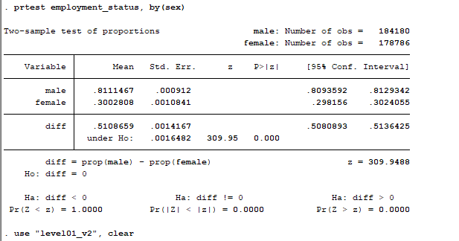

**Q6. Does the employment rate by principal status for females (aged 15-59) differ across expenditure deciles? Plot in a graph and comment.**

Yes the employment rate for females(aged 15-59) differ across expenditures deciles. The employment rate for females varies from approximately 41% in 1st decile group to 22% only in 10th decile group (Please refer to “Table9” sheet in test_results.xlsx file).

I plotted the line graph of employment rate for females and average monthly per capita consumption expenditure across decile groups. There is a negative relationship between ratio of female employed and average monthly per capita consumption expenditure. With the increase in per capita consumption expenditure, the employment rate for female decline drastically. This suggests per capita consumption expenditure of a household does act as an important determinant factor in taking employment decision of females of the household.